**Prac #5**

**Exercises on Normalisation Process**

**Note:**

Most exercise tasks included in this prac does not require to use MySQL Workbench. You can put your answer directly on the paper or WORD document for those tasks.

Some tasks requiring to draw the final normalised ERD, you will have to use MySQL Workbench.

* **Pre-requisites**

In order to complete exercises in this prac, you are assumed the knowledge of normalisation principles and procedures which was covered through recent lectures and relevant reading materials (Chapter 6 from Coronel-Morris textbook).

**[Pre-Exercise]**

**(This is just for your practice purpose only. It’s why the solution is provided.)**

**Given the dependency diagram shown below, answer items a ~ c:**



* 1. **Identify and discuss each of the indicated dependencies.**

**Sample Answers:**

* (C1**→**C2) represents a *partial dependency*, because C2 depends only on C1, rather than on the entire primary key composed of C1 and C3.
* (C4**→**C5) represents a *transitive dependency*, because C5 depends on an attribute (C4) that is not part of a primary key.
* (C1,C3 **→** C2,C4,C5) represents a set of proper functional dependencies, because C2, C4, and C5 depend on the primary key composed of C1 and C3.
  1. **Create a database whose tables are at least in 2NF, showing the dependency diagrams for each table.**

**Sample Answers:**



Instead of presenting these databases and relevant dependencies using graphical charts as shown above, you can simply present these using schema texts:

* Table 1 (C1 🡪 C2)
* Table 2 (C1, C3 🡪 C4, C5) with transitive dependency (C4 🡪 C5).

*Note: PK is presented using underline.*

1. **Create a database whose tables are at least in 3NF, showing the dependency diagrams for each table.**

**Sample Answers:**



Alternative presentation of this answers:

* Table 1 (C1 🡪 C2)
* Table 2 (C1, C3 🡪 C4)
* Table 3 (C4 🡪 C5).

**[Exercise 1]**

Using the STUDENT table structure shown in the table below, do the following (a~ c):

Sample STUDENT Records

|  |  |  |  |  |  |
| --- | --- | --- | --- | --- | --- |
| **Attribute Name** | **Sample Value** | **Sample Value** | **Sample Value** | **Sample Value** | **Sample Value** |
| STU_NUM | 211343 | 200128 | 199876 | 199877 | 223456 |
| STU_LNAME | Stephanos | Smith | Jones | Smith | McKulski |
| STU_MAJOR | Accounting | MBA | Marketing | Marketing | Statistics |
| DEPT_CODE | ACCT | ACCT | MKTG | MKTG | MATH |
| DEPT_NAME | Accounting | Accounting | Marketing | Marketing | Mathematics |
| DEPT_PHONE (representative number) | 4356 | 4356 | 4378 | 4378 | 3420 |
| COLLEGE_NAME | Business Admin | Business Admin | Business Admin | Business Admin | Arts & Sciences |
| ADVISOR_ID | 1001 | 1001 | 1442 | 1799 | 1902 |
| ADVISOR_LNAME | Grastrand | Grastrand | Gentry | Tillery | Chen |
| ADVISOR_OFFICE | T201 | T201 | T201 | T356 | J331 |
| ADVISOR_BLDG | Torre Building | Torre Building | Torre Building | Torre Building | Jones Building |
| ADVISOR_PHONE | 2115 | 2115 | 2123 | 2159 | 3209 |
| STU_GPA | 3.87 | 2.78 | 2.31 | 3.45 | 3.58 |
| STU_HOURS | 75 | 45 | 117 | 113 | 87 |
| STU_CLASS | Junior | Sophomore | Senior | Senior | Junior |

(Put your answers for task a and b in a WORD document. For c, you are required to draw the ERD using MySQL Workbench)

a. Draw its dependency diagram and identify all dependencies, including all transitive dependencies.

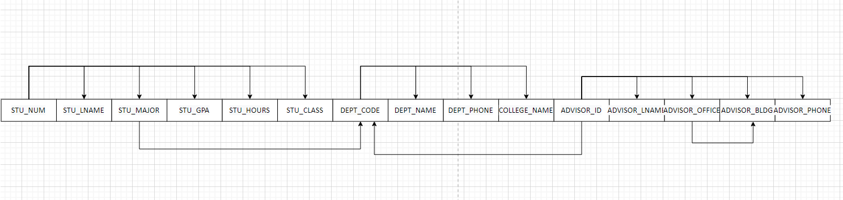

b. Write the relational schema and draw the dependency diagram to meet the 3NF requirements to the greatest extent possible. If you believe that practical considerations dictate using a 2NF structure, explain why your decision to retain 2NF is appropriate. If necessary, add or modify attributes to create appropriate determinants and to adhere to the naming conventions.

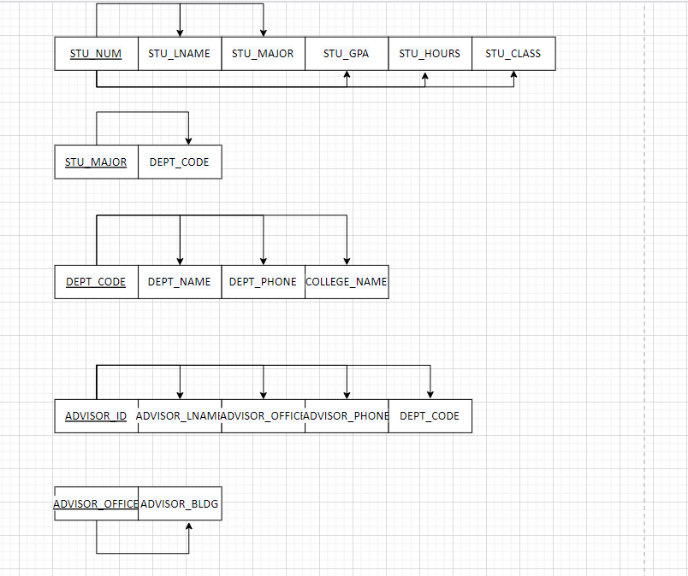

STUDENT (STU_NUM, STU_LNAME, STU_MAJOR, STU_GPA, STU_HOURS, STU_CLASS)

MAJOR (STU_MAJOR, DEPT_CODE)

DEPARTMENT (DEPT_CODE, DEPT_NAME, DEPT_PHONE, COLLEGE_NAME )

OFFICE (ADVISOR_OFFICE, ADVISOR_BLDG)

ADVISOR (ADVISOR_ID, ADVISOR_LNAME, ADVISOR_OFFICE, ADVISOR_PHONE, DEPT_CODE)

c. Draw the Crow’s Foot ERD.

**[Exercise 2 (additional exercise for advanced task)]**

**(This is just for your practice for advanced level of normalisation. The solution is not provided directly here but will be available later. If you want to try this advanced task, please try yourself !)**

The manager of a consulting firm has asked you to evaluate a database that contains the table structure shown below.

Sample CLIENT Records

|  |  |  |  |
| --- | --- | --- | --- |
| Attribute Name | **Sample Value** | **Sample value** | **Sample Value** |
| CLIENT_NUM | 298 | 289 | 289 |
| CLIENT_NAME | Marianne R. Brown | James D. Smith | James D. Smith |
| CLIENT_REGION | Midwest | Southeast | Southeast |
| CONTRACT_DATE | 10-Feb-2010 | 15-Feb-2010 | 12-Mar-2010 |
| CONTRACT_NUMBER | 5841 | 5842 | 5843 |
| CONTRACT_AMOUNT | $2,985,00.00 | $670,300.00 | $1,250,000.00 |
| CONSULT_CLASS_1 | Database Administration | Internet Services | Database Design |
| CONSULT_CLASS_2 | Web Applications |  | Database Administration |
| CONSULT_CLASS_3 |  |  | Network Installation |
| CONSULT_CLASS_4 |  |  |  |
| CONSULTANT_NUM_1 | 29 | 34 | 25 |
| CONSULTANT_NAME_1 | Rachel G. Carson | Gerald K. Ricardo | Angela M. Jamison |
| CONSULTANT_REGION_1 | Midwest | Southeast | Southeast |
| CONSULTANT_NUM_2 | 56 | 38 | 34 |
| CONSULTANT_NAME_2 | Karl M. Spenser | Anne T. Dimarco | Gerald K. Ricardo |
| CONSULTANT_REGION_2 | Midwest | Southeast | Southeast |
| CONSULTANT_NUM_3 | 22 | 45 |  |
| CONSULTANT_NAME_3 | Julian H. Donatello | Geraldo J. Rivera |  |
| CONSULTANT_REGION_3 | Midwest | Southeast |  |

This table was created to enable the manager to match clients with consultants. The objective is to match a client within a given region with a consultant in that region, and to make sure that the client’s need for specific consulting services is properly matched to the consultant’s expertise. For example, if the client need help with database design and is located in the Southeast, the objective is to make a match with a consultant who is located in the Southeast and whose expertise is in database design. (Although the consulting company manage tries to match consultant and client locations to minimize travel expense, it is not always possible to do so.) The following basic business rules are maintained:

* Each client is located in one region
* A region can contain many clients.
* Each consultant can work on many contracts
* Each contract might require the services of many consultants.
* A client can sign more than one contract, but each contract is signed by only one client.
* Each contract might cover multiple consulting classifications. (For example, a contract may list consulting services in database and networking.)
* Each consultant is located in one region.
* A region can contain many consultants.
* Each consultant has one or more areas of expertise (class). For example, a consultant might be classified as an expert in both database design and networking.
* Each area of expertise (class) can have many consultants in it. For example, the consulting company might employ many consultants who are networking experts.

1. Given that brief description of the requirements and the business rules, write the relational schema and draw the dependency diagram for the preceding (and very poor) table structure. Label all transitive and/or partial dependencies.
2. Break up the dependency diagram you drew in the previous problem segment (a) to produce dependency diagrams that are in 3NF. (*Hint*: You might have to create a few new attributes. Also make sure that the new dependency diagrams contain attributes that meet proper design criteria; that is, make sure that there are no multivalued attributes, that the naming conventions are met, and so on.)
3. Using the results of the previous problem segment (b), draw the Crow’s Foot ERD.

This is the end of Prac #5.

You are only required to complete [Exercise 1] and submit one WORD document containing your answers and the image of ERD created in MySQL Workbench. (Alternatively, you can submit the original Workbench file having the ERD).

[Exercise 2] is not required to submit. It is just for your own practice.